QUREO
2 CHAPTERS 6 LESSONS HANDS-ON ACTIVITIES

Agenda

CHAPTER 1 Introduction Open chapter →
1 | What is programming?  Programming as clear instructions for a computer | Go →
2 | Programming languages  HTML, CSS and JavaScript — what each one does | Go →
3 | The text editor  Where code is written · copy & paste shortcuts | Go →
4 | Printing in JavaScript  Your first code: console.log() | Go →
5 | Comments  Leaving notes for humans with // | Go →

CHAPTER 2 Calculations & Strings Open chapter →
1 | Strings & calculations  Doing maths and joining text in the same line of code | Go →
 | ↳ Strings vs. calculations | Go →
 | ↳ Arithmetic operators | Go →
 | ↳ Combining strings and calculations | Go →
 | ↳ Challenge: choose the right code | Go →

CHAPTER 1

Introduction

LESSON 1 What is programming?
Programming is the process of writing instructions that tell a computer exactly what to do.
Computers only understand binary code (Zeros and Ones), so programming acts as a translator between human logic and computer logic.
بالعربي
تخيل ان انت عايز تدي حد وصفة الكيكة عشان يعملهالك ف انت مش هتروح تقولو اعملي كيكة بس. لازم تقولو كل حاجة بالحرف في الوصفة دي ( حط كوبايتين دقيق – حط 3 بيضات – قلبهم لمدة دقيقتين).
دي نفس فكرة البرمجة بالظبط. انك تدي اوامر للجهاز عشان ينفذ الي انت عايزو وبنستخدم لغات البرمجة عشان نكتب الاوامر دي.

LESSON 2 Programming languages
- Programming allows you to create games, websites, applications, etc.
- There are more than 100 programming languages in the world.
- Different programming languages are good at different things.

■ Differences in languages
We will learn 3 types: HTML, CSS, and JavaScript
HTML  (THE STRUCTURE)  HTML provides the basic foundation and raw content. Just as the wooden framing and bricks define the rooms of a house, HTML defines what elements exist on the page—like the paragraphs, images, buttons, and links. | CSS  (THE STYLE)  CSS controls the appearance and design. Like the paint, wallpaper, and interior decorating of a house, CSS takes the raw HTML structure and dictates its colors, fonts, spacing, and layout to make it look visually appealing. | JavaScript  (THE INTERACTIVITY)  JavaScript adds behavior and logic. Like the electricity, plumbing, and smart home system, JavaScript makes the webpage actually do things. It handles actions like opening a popup menu, updating live data, or submitting a form without forcing you to reload the page.

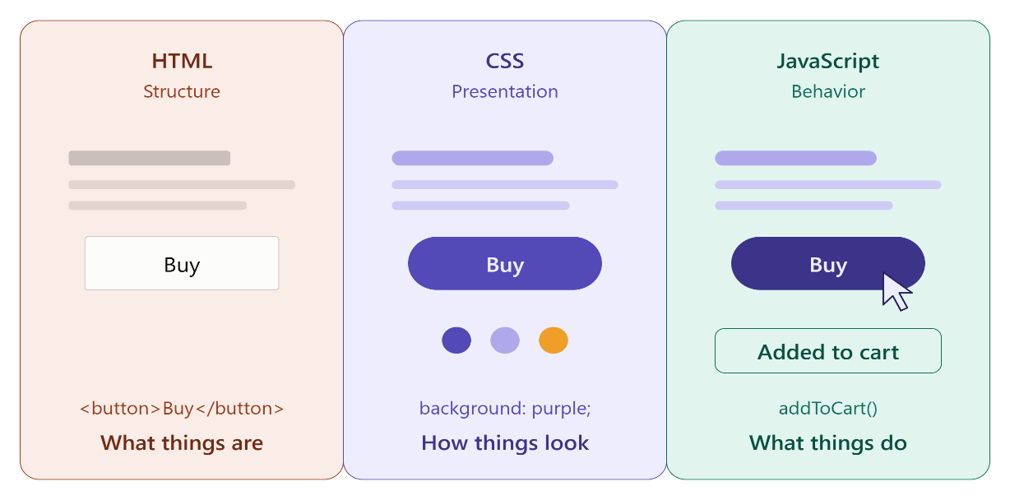

NOTE
HTML and CSS aren’t programming languages; HTML is a markup language, and CSS is a stylesheet language

LESSON 3 The text editor
- The place where you write your program is called a text editor (console)
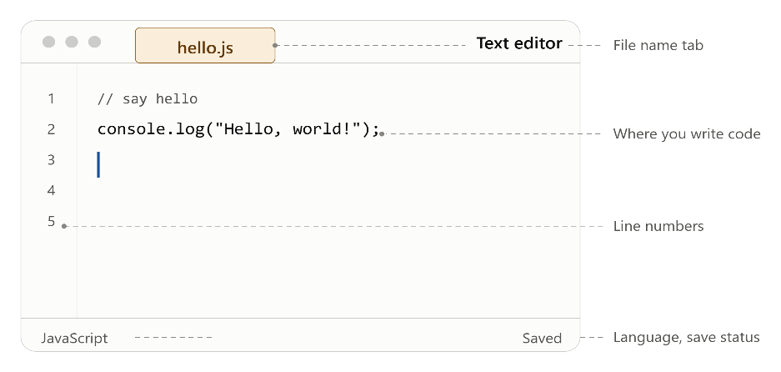

(console.log is the code for printing in JavaScript, and we will learn it later)
- Programs are written in programming languages, not in ordinary characters
SHORTCUTS
You copy text by pressing Ctrl + C
And you paste it by pressing Ctrl + V

LESSON 4 Printing in JavaScript
In this lesson, we will start writing code in JavaScript. We will write on Visual Studio Code لحد م ربنا يفرجها ونخش المنصة
The first code we will study is the printing code in JS:
console.log();

Ex:
console.log("Hello World");

The output of this code will be Hello World (الي هيطلع هو الي انت كتبتو بالظبط)
The words or sentence you want to print is called a string, and it must be written between quotation marks
If you wrote:
WRONG
console.log(Hello World);

The output will be an error because you didn’t write the string in quotation marks
Also, if there is a missing character in the code or a capital letter, the output will be an error
NOTE
This code can be written with a semicolon or without it. Both are right:
console.log("Hello World");
console.log("Hello World")

ACTIVITY
Open Visual Studio Code now and write this code correctly to get the output (Hello World)

LESSON 5 Comments

■ First, what is a comment?
A comment is text you place inside the program for humans to read. The computer completely ignores it when running the program.
بالعربي
الكومنت دا كلام انت بتكتبو في البروجرام لنفسك او ل اي حد عشان يفهم الكود دا بيعمل ايه وكدا
ممكن تكتب اي حاجة في الكومنت عادي
الكومنت مش بيتحسب ك كود هو كلام عادي

■ How to leave a comment in the console?
You put 2 slashes before the sentence to write a comment
Ex:
// Hello there

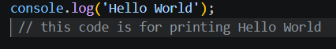

In this image, I wrote code, and I left a comment for myself to remember what this code does
ACTIVITY 1
You have to write code to achieve those outputs and write a comment for yourself:
OUTPUT
Good morning
Hello
Good evening

بالعربي
لازم تفتح ستوديو كود وتجرب بنفسك قبل م تشوف الاجابة

THE MODEL ANSWER
//Greetings for the day
console.log("Good morning");
console.log("Hello");
console.log("Good evening");

ACTIVITY 2
You have these lines of code:
console.log("Eggs");
console.log("Apple");
console.log("Milk");
And I want the output to be only:
OUTPUT
Eggs
Milk
Without deleting any line of code

THE MODEL ANSWER
You will put // before the second line of code to make it a comment

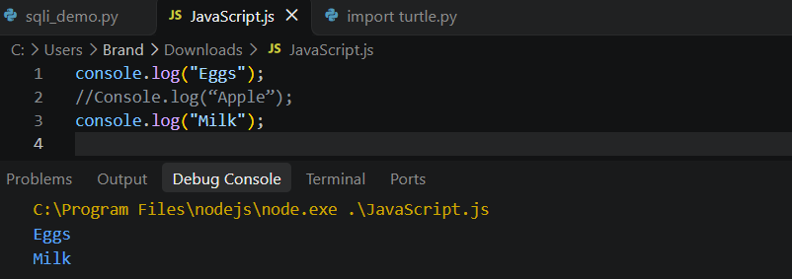

CHAPTER 2

Calculations & Strings

LESSON 1 Strings & calculations

■ Strings vs. calculations
If you write in the program:
console.log("1+1");

THINK ABOUT IT
What will the output be? Think about it for a moment.

The output will be 1+1, but how is that?
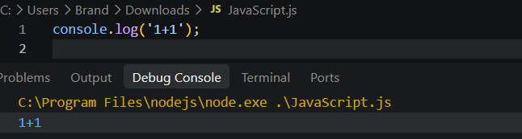

Because you wrote a string, not a calculation process
1+1 is written in quotation marks, so it’s a string that will be printed as it is
If you want to perform a calculation, you will write it as follows:
console.log(1+1);

(without quotation marks)
In this case, the output will be 2
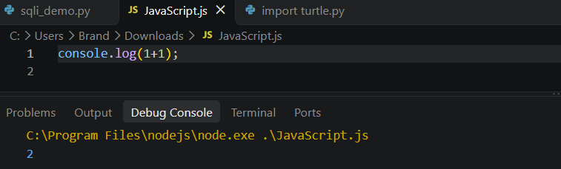

ACTIVITY
Make the computer calculate (1400+3600)
(Try it in Visual Studio Code)

THE MODEL ANSWER
console.log(1400+3600);

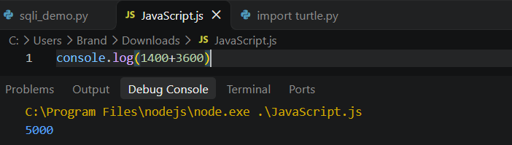

NOTE
(you don’t have to put quotation marks when printing numbers)

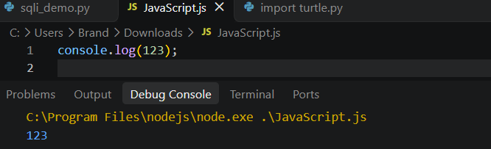

■ Arithmetic operators
We use different symbols for multiplication and division processes
We use **( * ) for multiplication and ( / )** for division
Ex:
console.log(5*9)
console.log(10/2)

Addition, subtraction, multiplication, and division are arithmetic operations
+ - * / are the operators
+  ADDITION | -  SUBTRACTION | *  MULTIPLICATION | /  DIVISION

ACTIVITY
Make the computer calculate (5 times 6) and (100 divided by 2)
(Write it yourself)

THE MODEL ANSWER
console.log(5*6);
console.log(100/2);

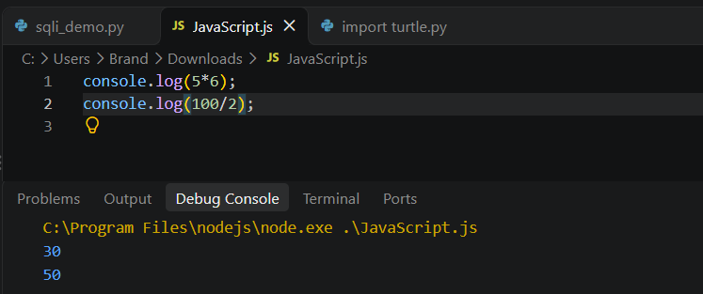

■ Combining strings and calculations
You can combine a string and a calculation in the same line of code
console.log("set of 2 coffees " + (250*2) + " pounds");

The output of this code will be:
OUTPUT
set of 2 coffees 500 pounds

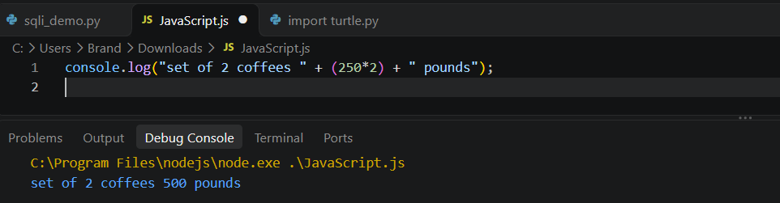

If you forget the + , you will get a syntax error
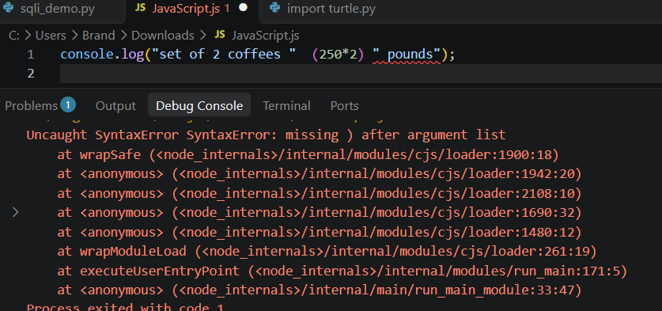

ACTIVITY
Write code to get this output:
OUTPUT
Today’s recommendation is soup.
Limited to 30 servings.
Using the combination method

THE MODEL ANSWER
console.log("Today's recommendation is " + "soup.");
console.log("Limited to " + 30 + " servings.");

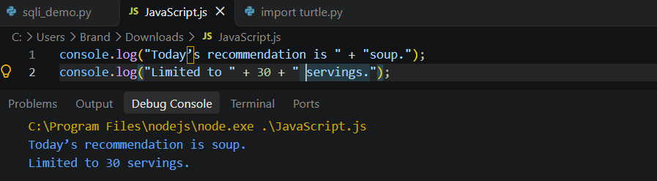

■ Challenge: choose the right code
In this activity, you must know the right code to give this output:
OUTPUT
Today is the 17th. 7 days ago was the 10th

A | console.log("Today is the 17th. 7 days ago was the " + 17 - 7 + "th.");
B | console.log("Today is the 17th. 7 days ago was the " + (17 - 7) + "th.");
C | console.log("Today is the 17th. 7 days ago was the (17 - 7)th.");
D | console.log("Today is the 17th. 7 days ago was the " + "17 - 7" + "th.");

THE MODEL ANSWER IS · OPTION B
console.log("Today is the 17th. 7 days ago was the " + (17 - 7) + "th.");

